搭建Java Web开发环境

Linux环境：CentOS 6.8 64位  
JDK版本：jdk1.8.0_151  
Tomcat版本：v8.5.24  
MySQL版本：Ver 14.14 Distrib 5.6.38

1. JDK安装  
   JDK 是开发Java程序必须安装的软件，可以用 yum 源里面的 JDK：

[root@localhost ~]# yum list java*

选择合适版本的JDK，并安装：

[root@localhost ~]# yum install -y java-1.8.0-openjdk-src.x86_64

安装完成，查看版本信息：

[root@localhost ~]# java -version

openjdk version "1.8.0_212"

OpenJDK Runtime Environment (build 1.8.0_212-b04)

OpenJDK 64-Bit Server VM (build 25.212-b04, mixed mode)

1. Tomcat安装  
   进入本地文件夹

[root@localhost ~]# cd /usr/local/

使用Tomcat官网 的下载链接，下载到服务器中：

[root@localhost local]# wgethttps://mc.qcloudimg.com/static/archive/fa66329388f85c08e8d6c12ceb8b2ca3/apache-tomcat-7.0.77.tar.gz

解压，并重命名

[root@localhost local]# tar -zxf apache-tomcat-7.0.77.tar.gz

[root@localhost local]# mv apache-tomcat-7.0.77 /usr/local/tomcat7.0.77

进入 bin 文件夹，给这个文件夹下的所有 shell 脚本授予权限：

[root@localhost local]# cd /usr/local/tomcat7.0.77/bin/

[root@localhost bin]# chmod 777 *.sh

开启tomcat服务：

[root@localhost bin]# ./startup.sh

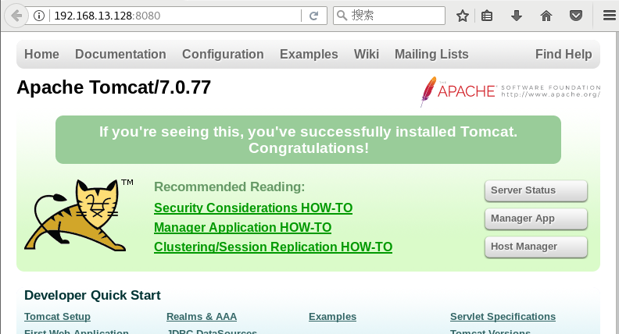

1. ****MySQL安装****

[root@localhost ~]# yum install -y mysql-server mysql mysql-devel

[root@localhost ~]# service mysql restart (启动服务)

Redirecting to /bin/systemctl restart mysql.service

Failed to restart mysql.service: Unit not found.

如安装mysql时启动服务失败可参照如下

有两种解决办法：

1. 安装mariadb
2. 官网下载安装mysql-server

# wget http://dev.mysql.com/get/mysql-community-release-el7-5.noarch.rpm

# rpm -ivh mysql-community-release-el7-5.noarch.rpm

# yum install mysql-community-server

安装成功后重启mysql服务。

# service mysqld restart

初次安装mysql，root账户没有密码。

[root@localhost ~]# mysql -u root

Welcome to the MySQL monitor. Commands end with ; or \g.

Your MySQL connection id is 2

Server version: 5.6.44 MySQL Community Server (GPL)

Copyright (c) 2000, 2019, Oracle and/or its affiliates. All rights reserved.

Oracle is a registered trademark of Oracle Corporation and/or its

affiliates. Other names may be trademarks of their respective

owners.

Type 'help;' or '\h' for help. Type '\c' to clear the current input statement.

mysql> show databases;

+--------------------+

| Database |

+--------------------+

| information_schema |

| mysql |

| performance_schema |

+--------------------+

3 rows in set (0.00 sec)

[root@localhost ~]# mysql --version

mysql Ver 14.14 Distrib 5.6.44, for Linux (x86_64) using EditLine wrapper